St Andrew’s Church
Orford with Longford

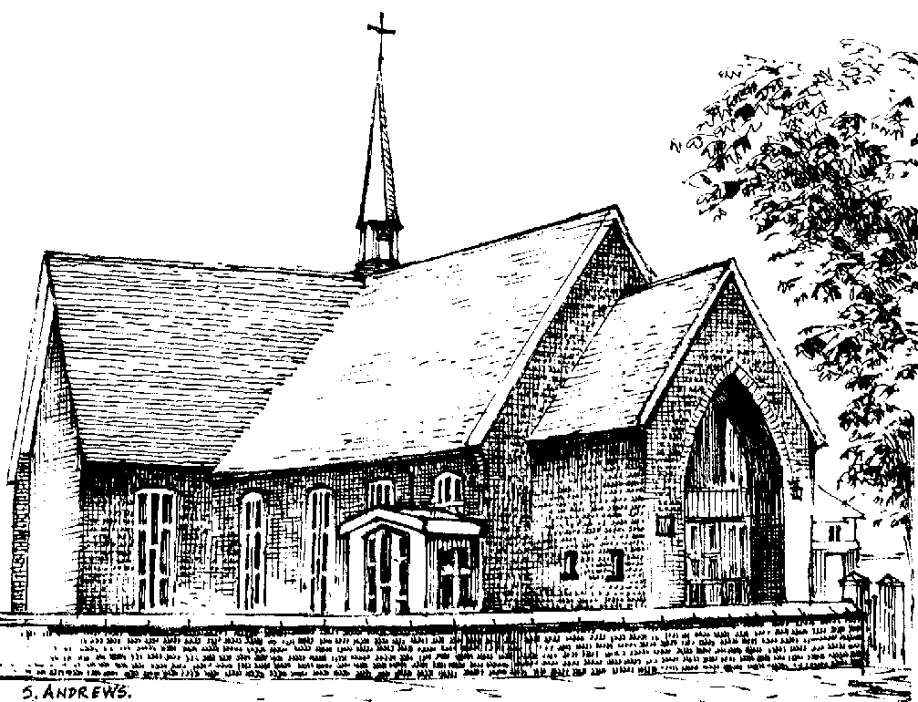

Herbert Hayes

25th March 1930 - 1st November 2012

Tuesday 13th November 2012

Order of Service

Please stand as the family enters to “Fields of Gold”. Please sit once the family are seated.

Introduction

All: Merciful Father, hear our prayers and comfort us; renew our trust in your Son, whom you raised from the dead; strengthen our faith that all who have died in the love of Christ will share in his resurrection; who lives and reigns with you, in the unity of the Holy Spirit, one God, now and for ever. Amen

Hymn: “Amazing Grace”

Amazing grace,
How sweet the sound that saved a wretch like me.
I once was lost but now I'm found,
Was blind, but now can see.

'Twas grace that taught my heart to fear,
And grace my fears relieved,
How precious did that grace appear
The hour I first believed.

Through many dangers, toils and snares,
I have already come.
'Tis grace hath brought me safe thus far,
And grace will lead me home.

The Lord has promised good to me;
His word my hope secures.
He will my shield and portion be
As long as life endures.

The Ministry of the Word

The Scriptural Reading (John 14. 1-6)

The Address including a tribute by Cheryl and the family

A Reflection: “My old man’s a dustman” by Lonnie Donegan

The Prayers:

Each section concludes:
Lord, in your mercy
All: hear our prayer.

After the final section:
God of mercy, entrusting into your hands all that you have made and rejoicing in our communion with all your faithful people, we make our prayers through Jesus Christ our Saviour. Amen.

The Lord’s Prayer

All: Our Father, who art in heaven, hallowed be thy name; thy kingdom come; thy will be done; on earth as it is in heaven. Give us this day our daily bread. And forgive us our trespasses, as we forgive those who trespass against us. And lead us not into temptation; but deliver us from evil. For thine is the kingdom, the power and the glory, for ever and ever. Amen

Hymn: “Abide with me”

Abide with me; fast falls the eventide:
the darkness deepens; Lord, with me abide:
when other helpers fail, and comforts flee,
help of the helpless, O abide with me.

Swift to its close ebbs out life's little day;
earth's joys grow dim, its glories pass away;
change and decay in all around I see:
O thou who changest not, abide with me.

I need thy presence every passing hour;
what but thy grace can foil the tempter's power?
Who like thyself my guide and stay can be?
Through cloud and sunshine, Lord, abide with me.

I fear no foe with thee at hand to bless;
ills have no weight, and tears no bitterness,
Where is death's sting? Where, grave, thy victory?
I triumph still, if thou abide with me.

Hold thou thy cross before my closing eyes;
shine through the gloom, and point me to the skies:
heaven's morning breaks, and earth's vain shadows flee;
in life, in death, O Lord, abide with me.

Commendation and Farewell

All: Heavenly Father, in your Son Jesus Christ you have given us a true faith and a sure hope. Strengthen this faith and hope in us all our days, that we may live as those who believe in the communion of saints, the forgiveness of sins and the resurrection to eternal life; through Jesus Christ our Lord. Amen.

The procession leaves to “You’ll never walk alone”

Acknowledgement: Common Worship: Pastoral Services, material from which is included in this service, is copyright © The Archbishops’ Council (2000)

